**Cost understanding**

**Support document**

1. *Differences between prototype and mass production*

Different types of manufacturing processes: Machining (Milling, Turning), Laser and waterjet cut, 3D printing, Stamping, Foundry, Forging, Broaching, Weldments, Injection molding, …

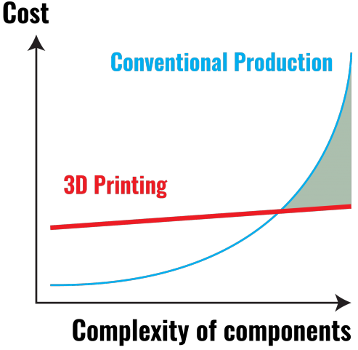

*Comparison of 3D printing versus conventional production: cost versus complexity*

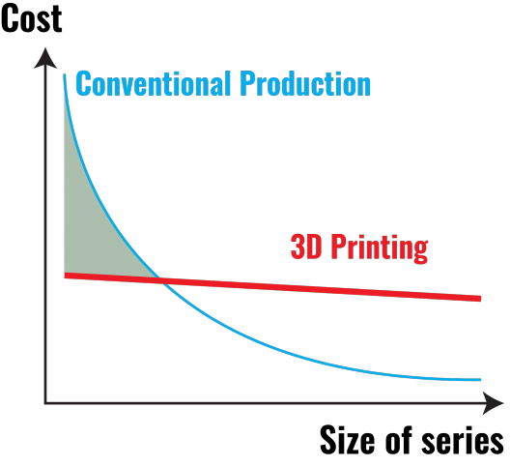

*Comparison of 3D printing versus conventional production: cost versus size of series*

Pour le support oral :

* Mettre courbes précédentes
* Exemple de pieces réalisés en série ou grosse production
  + Triangles carbones et acier (mécano soudé)
  + Pour admission, truc en injection plastique ? (admission Dynamix ?)
  + Pour échappement, passage d’un 4 en 2 en 1 à un rateau ?

1. *Resource and cost planning*

*Global resource planning*

See V cycle drawing.

|  |  |  |  |
| --- | --- | --- | --- |
| **End of…** | **Previsionnal date** | **Real date** | **Delay (in days)** |
| High level design | 6 sept. 2018 | 13 sept. 2018 | **7 days** |
| Detailed design | 13 nov. 2018 | 20 nov. 2018 | **7 days** |
| Fabrication & unit testing | 15 feb. 2019 | 8 mar. 2019 | **21 days** |
| System testing & integration | 16 mar. 2019 | 5 apr. 2019 | **20 days** |
| Roll out | 10 apr. 2019 | 10 apr. 2019 | **0 days** |
| First testing | 20 apr. 2019 | 27 apr. 2019 | **7 days** |

*Detailed resource planning*

Utilisation of Gantts to plan and monitor the work.

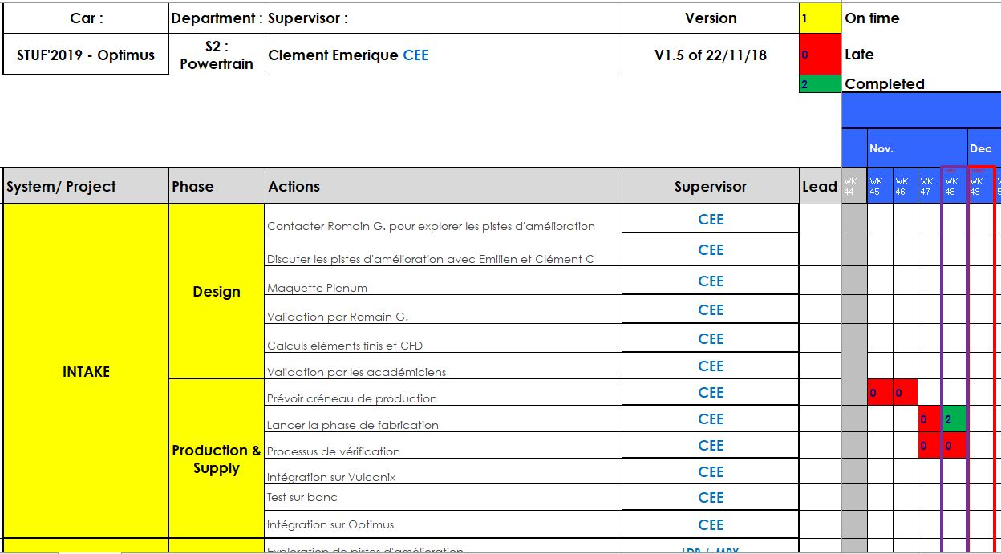

*Example of Gantt layout*

*Manufacturing planning*

* Gantt of the production phase (Manufacturing_Gantt)
* Excel of the repartition of the production between our partners, sponsors and suppliers (Manufacturing_framework)

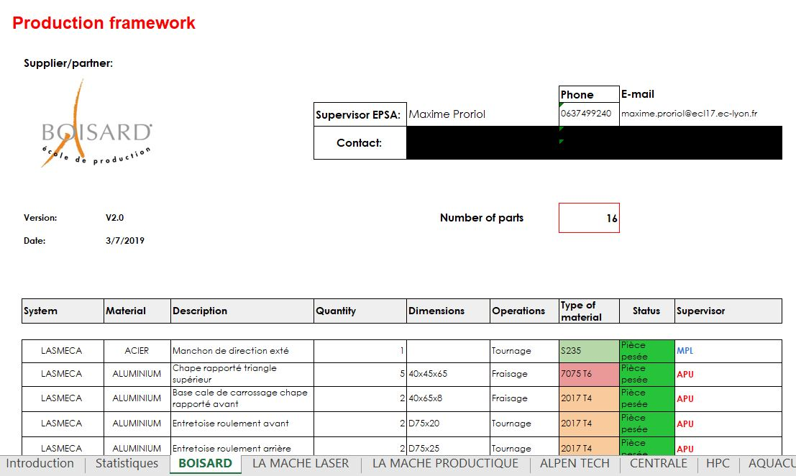

*Production framework layout*

*Cost planning*

See *Previsionnal Expenses* drawing.

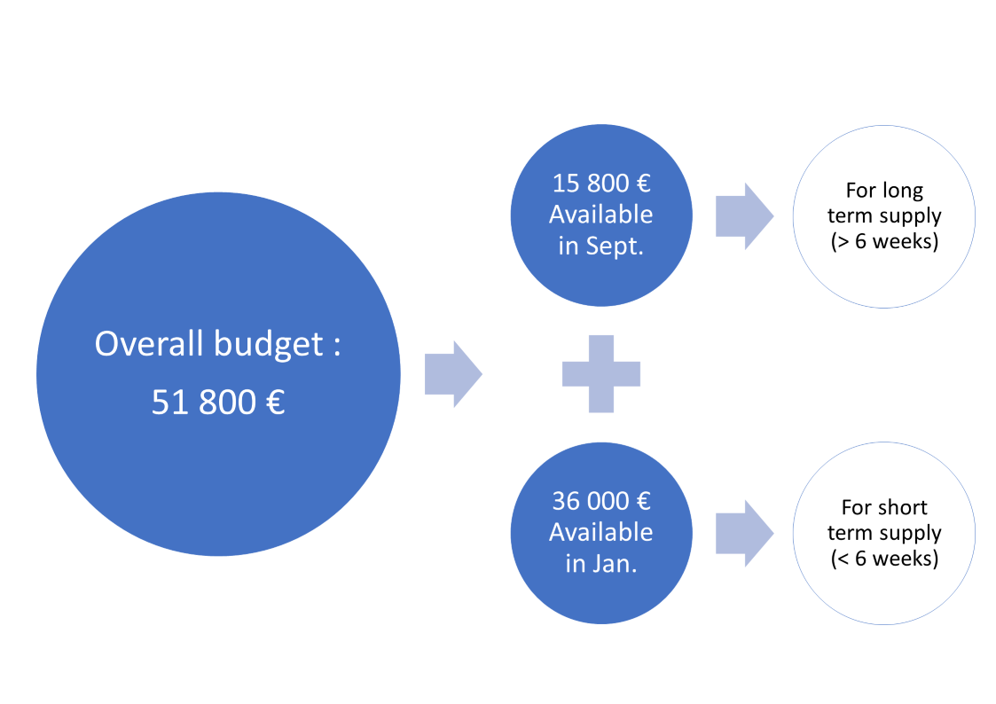

*Example of Gantt layout*

|  |  |  |  |  |
| --- | --- | --- | --- | --- |
| **System** | **Previsionnal** | **Real** | **Differences (€)** | **Differences (%)** |
| Suspension | 12 630,00 € | 19 480,00 € | 6 850,00 € | 35% |
| Powertrain | 14 680,00 € | 14 046,00 € | -634,00 € | -5% |
| Electrical | 6 810,00 € | 6 893,00 € | 83,00 € | 1% |
| Frame & body | 880,00 € | 2 005,00 € | 1 125,00 € | 56% |
| Miscellaneous | 11 400,00 € | 9 994,00 € | -1 406,00 € | -14% |
| Total | 46 400,00 € | 52 418,00 € | 6 018,00 € | 11% |
| Budget | 51 800,00 € | 52 600,00 € |  |  |
| Financial provisions | 5 400,00 € | 182,00 € |  |  |

*Summary of previsionnal and real expenses*

1. *Financial and production risk management*

*An example of a financial risk*

Supply of wheels’ bearings:

* Delay of delivery due to absence of stock
  + Initially planned on March
  + Delivery delayed to the beginning of June
* To respect the roll-out deadline, wheels bearings supplied with the budget
  + Diminution of the financial provision

*An example of a production risk*

A fire destroyed the workshops of our partner during the manufacturing of the uprights and hubs. The team reacted quickly to move the production to another partner and to the university workshop.

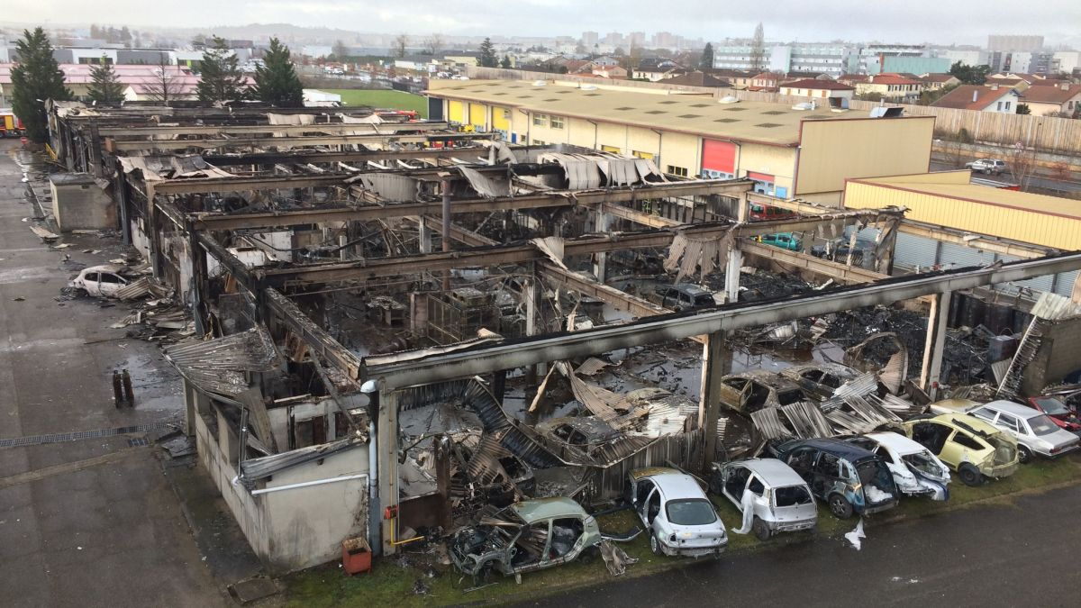

*Fire in the workshops of our partner Boisard*

1. *Make or buy decisions*

See ratio of price versus weight saved.

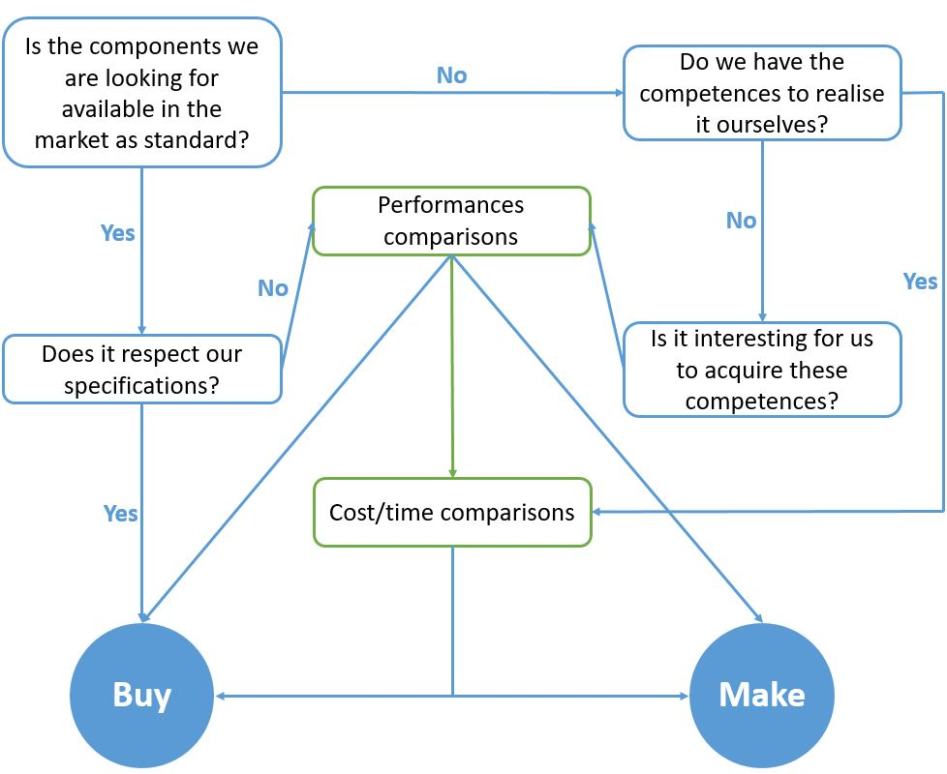

*Diagram to illustrate buy and made decisions*

Rajouter Chemins de decisions pour certains composants du véhicule ?

1. *Environmental influence of the vehicle production*

Emulsion huile de coupe

Recyclage copeaux + parts

Recyclage huiles

Réutilisation composant acheté dans le commerce ou années précédentes

Réflexion autour E95

Réutilisation de motos accidentées

Prise en compte environnement dans perfo (mais poids faible car véhicule compétition)

Supports :

* Recycling of CFRP and other materials, oils, …
* Second life for standard part
* During production (limitate raw materials used, oil lubrification, traitement des copeaux, …)
* Recycling of tires : <https://www.youtube.com/watch?v=QLYQssSvnzk>
  + <https://www.youtube.com/watch?v=UczKhE6Cbhg>
* For gasoline : Thinking about E85

1. *Effectiveness of financial planning*

Général : **Terme de paiement**, quand acheter matos, … (cashflow)

1. *Methods for software development cost calculation*

Etudes des besoins -> spécifications des différentes fonctions ->

Couts = programmation mais aussi discussion avec client (inexistant en usinage avec normes mises en plan ou plutôt sur faisabilité), vérifications des codes, mutualisation des fonctions, backend et front end, débeugage (unitaire et global), éventuellement installation

Vente logiciel générique -> Temps de dvlp, volume de vente, ajouts de fonctionnalités, vente en packaging/modules annexes, rajout modules dans le temps -> vient du business plan

Questions récurrentes :

* The part the most expensive on the car and its price?
* How many parts on the car?
* Price of the vehicle?
* If you had money issue, what would you do to resolve it?
* If you wanted to reduce environmental influence of the vehicle, what part would you change?
* Examples of part you would change from prototype to mass production?